SOURCE DATA: FB TTS
Total Population | 126,014,024
Active Population | 10,260,557
Coverage | 8.142393
Total areas from SHP file | 2,469
Areas from total population | 2,469
Areas from active population | 2,084
Missing values areas | 385
Areas after missing values treatment | 2,084
Negative bias areas | 7
Areas after negative bias treatment | 2,077
Pearson correlation | 0.8621993118654
Weight generation
Spatial component | Islands or unconnected areas
Queen | 40
Knn (k = 4) | 1

Spatial weights matrix | P-Value | Moran’s I
Non-spatial | - | -
Queen | 0 | 0.265059268
Knn | 0 | 0.304579777

METRIC | Non-spatial |  | Queen |  | Knn
 | Training | Test | Training | Test | Training | Test
RMSE_0 | 0.16944 | 0.3901 | 0.24863 | 0.33369 | 0.23719 | 0.35026
RMSE | 0.02475 | 0.08695 | 0.0369 | 0.07557 | 0.0352 | 0.07932
RMSE_Metrics | 0.02475 | 0.08695 | 0.0369 | 0.07557 | 0.0352 | 0.07932
RMSE_caret | 0.02475 | 0.08695 | 0.0369 | 0.07557 | 0.0352 | 0.07932
MSE_Metrics | 6.1e-4 | 0.00756 | 0.00136 | 0.00571 | 0.00124 | 0.00629
MAE_Metrics | 0.01586 | 0.04492 | 0.02215 | 0.04033 | 0.0216 | 0.04039
MAE_caret | 0.01586 | 0.04492 | 0.02215 | 0.04033 | 0.0216 | 0.04039
MAPE_Metrics | 0.08895 | 0.07081 | 0.14111 | 0.06406 | 0.11352 | 0.06422
RMSLE_Metrics | 0.01473 | 0.05188 | 0.02236 | 0.04542 | 0.02081 | 0.04771
R2 | 0.9273 | -0.14386 | 0.83842 | 0.13602 | 0.85295 | 0.04811
R2_caret | 0.94438 | 0.0896 | 0.86805 | 0.19133 | 0.8783 | 0.1619
R2_yardstick | 0.94438 | 0.0896 | 0.86805 | 0.19133 | 0.8783 | 0.1619
RMSE_yardstick | 0.02475 | 0.08695 | 0.0369 | 0.07557 | 0.0352 | 0.07932
Pearson_Cor | 0.97179 | 0.29933 | 0.93169 | 0.43742 | 0.93718 | 0.40237
Pearson_P_Value | 0 | 0 | 0 | 0 | 0 | 0
Spearman_Cor | 0.90479 | 0.53015 | 0.85484 | 0.59026 | 0.85001 | 0.63459
Spearman_P_Value | 0 | 0 | 0 | 0 | 0 | 0
SD_Error | 0.02476 | 0.08649 | 0.03691 | 0.07537 | 0.03521 | 0.07896

TTS
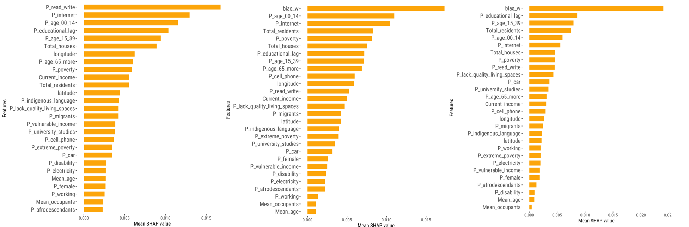
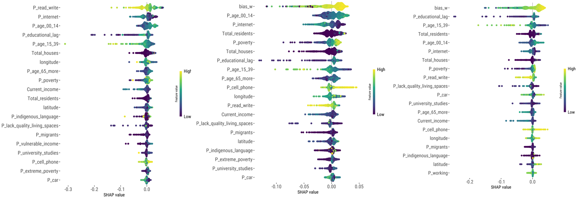

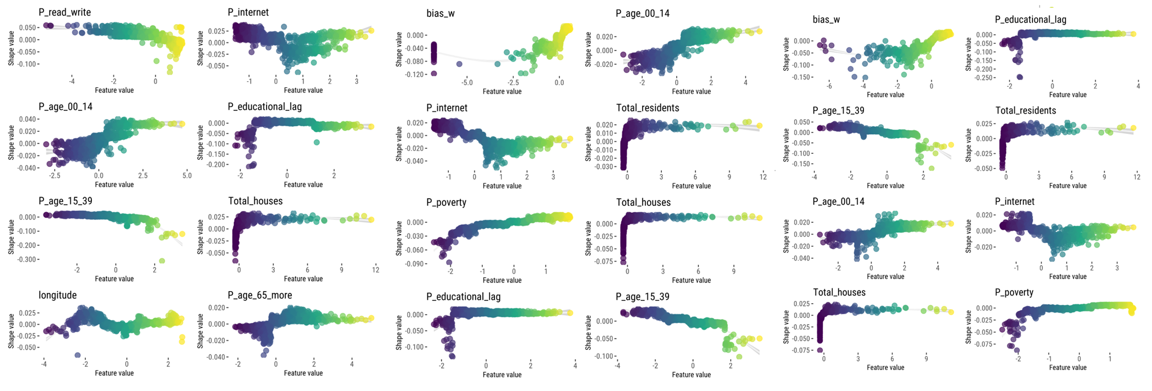
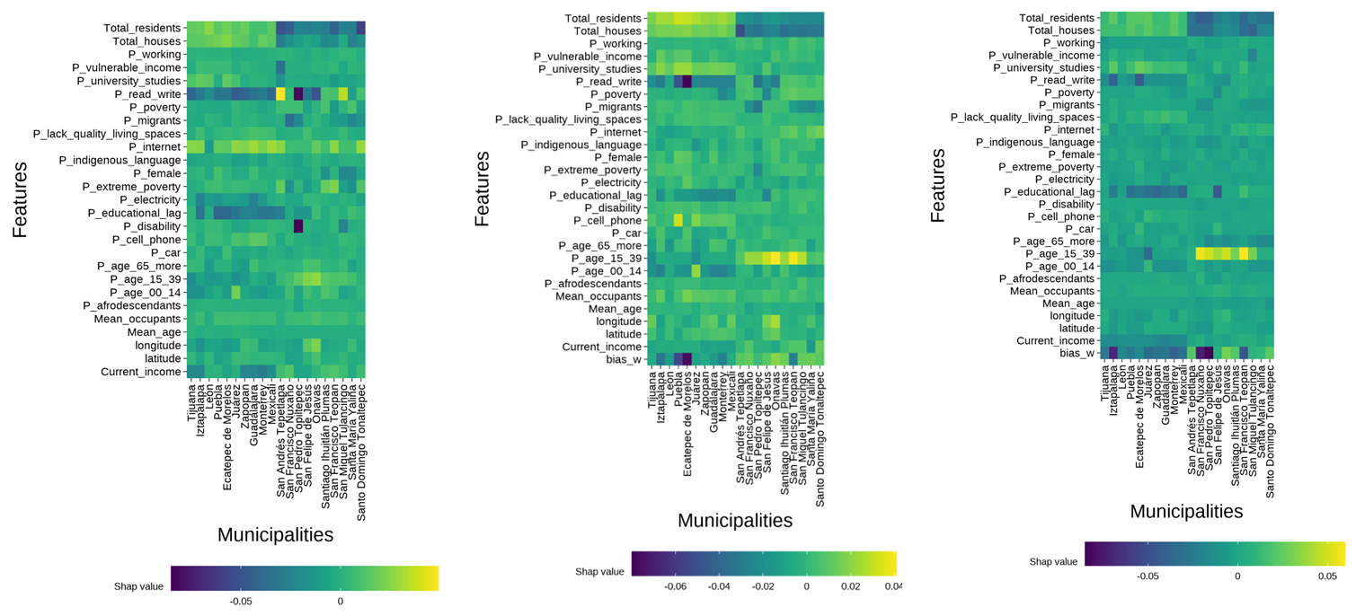

SOURCE DATA: PHONE 00_05
Total Population | 126,014,024
Active Population | 971,105
Coverage | 0.7706325
Total areas from SHP file | 2,469
Areas from total population | 2,469
Areas from active population | 2,461
Missing values areas | 8
Areas after missing values treatment | 2,461
Negative bias areas | 0
Areas after negative bias treatment | 2,461
Pearson correlation | 0.950861409795675
Weight generation
Spatial component | Islands or unconnected areas
Queen | 63
Knn (k = 3) | 1

Spatial weights matrix | P-Value | Moran’s I
Non-spatial | - | -
Queen | 0 | 0.60272196
Knn | 0 | 0.66860867

METRIC | Non-spatial |  | Queen |  | Knn
 | Training | Test | Training | Test | Training | Test
RMSE_0 | 0.00396 | 0.00707 | 0.00345 | 0.00707 | 0.00466 | 0.00707
RMSE | 5.3e-4 | 0.00145 | 4.7e-4 | 0.00147 | 6.4e-4 | 0.00147
RMSE_Metrics | 5.3e-4 | 0.00145 | 4.7e-4 | 0.00147 | 6.4e-4 | 0.00147
RMSE_caret | 5.3e-4 | 0.00145 | 4.7e-4 | 0.00147 | 6.4e-4 | 0.00147
MSE_Metrics | 0 | 0 | 0 | 0 | 0 | 0
MAE_Metrics | 3.9e-4 | 8.3e-4 | 3.5e-4 | 8.4e-4 | 4.6e-4 | 8.6e-4
MAE_caret | 3.9e-4 | 8.3e-4 | 3.5e-4 | 8.4e-4 | 4.6e-4 | 8.6e-4
MAPE_Metrics | 3.9e-4 | 8.3e-4 | 3.5e-4 | 8.4e-4 | 4.6e-4 | 8.6e-4
RMSLE_Metrics | 2.7e-4 | 7.3e-4 | 2.4e-4 | 7.4e-4 | 3.2e-4 | 7.4e-4
R2 | 0.97026 | 0.78235 | 0.9766 | 0.77544 | 0.95743 | 0.77514
R2_caret | 0.97124 | 0.78266 | 0.97724 | 0.77589 | 0.95827 | 0.77558
R2_yardstick | 0.97124 | 0.78266 | 0.97724 | 0.77589 | 0.95827 | 0.77558
RMSE_yardstick | 5.3e-4 | 0.00145 | 4.7e-4 | 0.00147 | 6.4e-4 | 0.00147
Pearson_Cor | 0.98552 | 0.88468 | 0.98855 | 0.88085 | 0.97891 | 0.88067
Pearson_P_Value | 0 | 0 | 0 | 0 | 0 | 0
Spearman_Cor | 0.96898 | 0.87248 | 0.97443 | 0.87121 | 0.95838 | 0.87111
Spearman_P_Value | 0 | 0 | 0 | 0 | 0 | 0
SD_Error | 5.3e-4 | 0.00145 | 4.7e-4 | 0.00147 | 6.4e-4 | 0.00147

PHONE 05
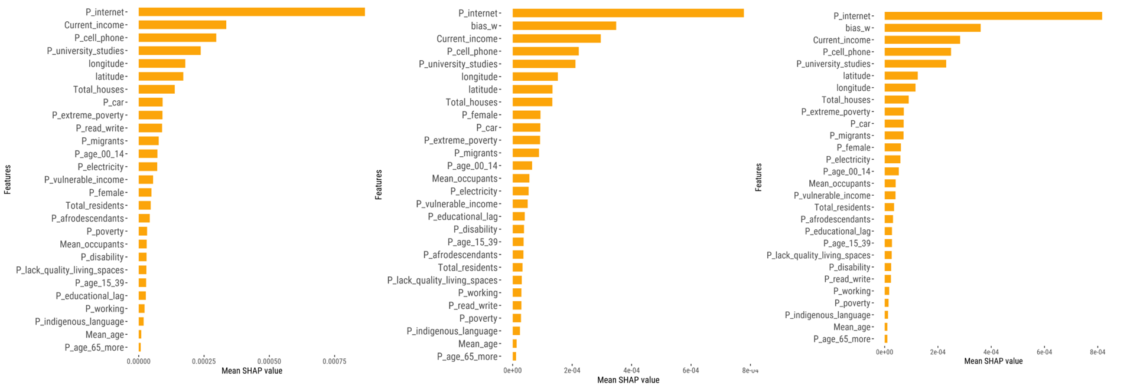
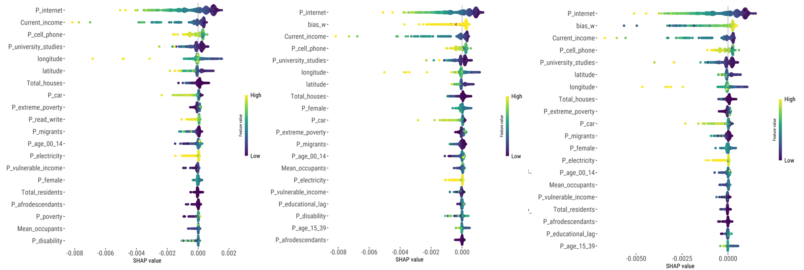
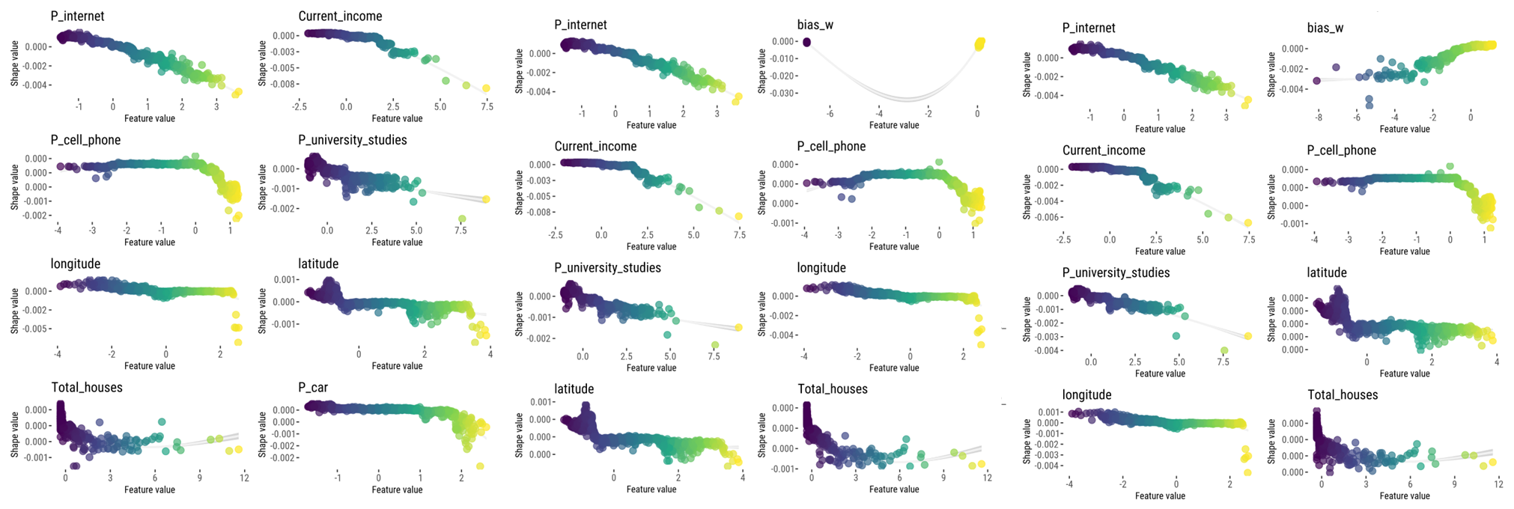
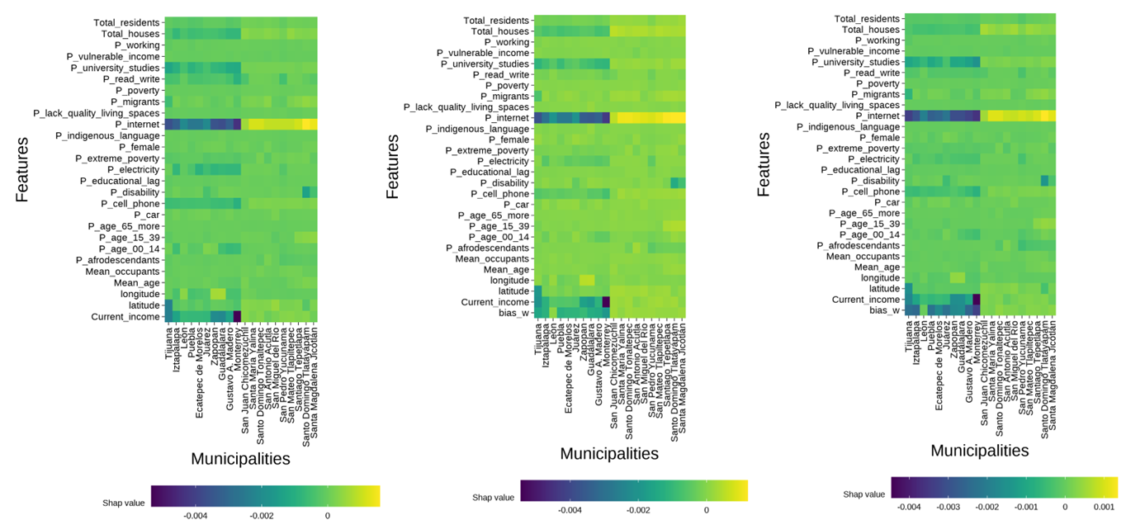




Tareas:
Documento de resultados en la misma hoja
Gráfico de puntos (para feature importance) e incluir la desviación estándar de intervalos de confianza
Desviación estándar de los feature importance

Shap dependence, quitar línea o traza, inferno y cambiar nombre
Summary plot violín
https://towardsdatascience.com/using-shap-values-to-explain-how-your-machine-learning-model-works-732b3f40e137/
Escala inferno

Nombres de variables más gramáticales

% internet
% population 65+
% pop 65+

Formato, tipo de letra y posición
Clases de Miguel

